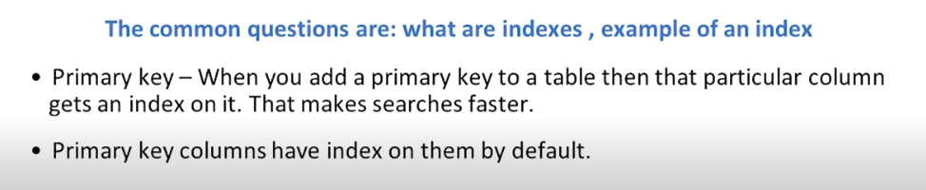

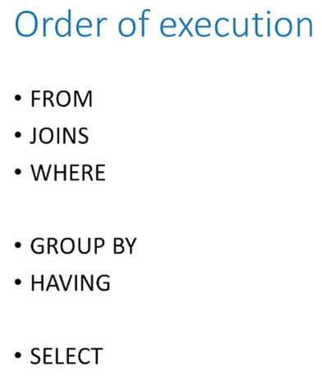

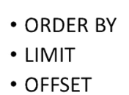

Python:

int is -infinity to +infinity

complex number is 4+3j

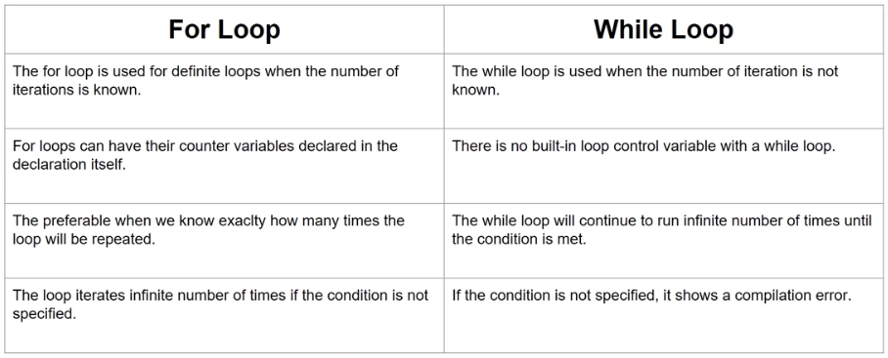

return terminates the loop once condition satisfies.

Break terminates the loop at any point when condition doesn’t satisfy.

Continue is when you don’t want to execute that block but want to continue to the next block of the loop.

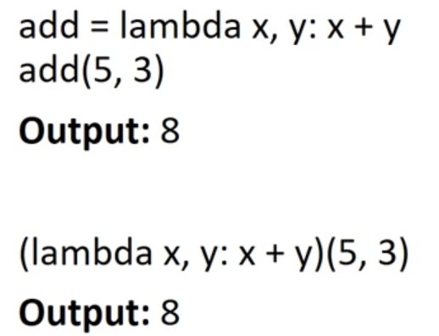

__________________________________________

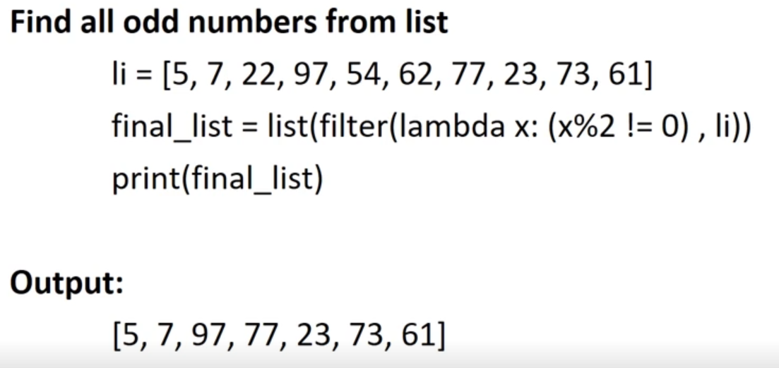

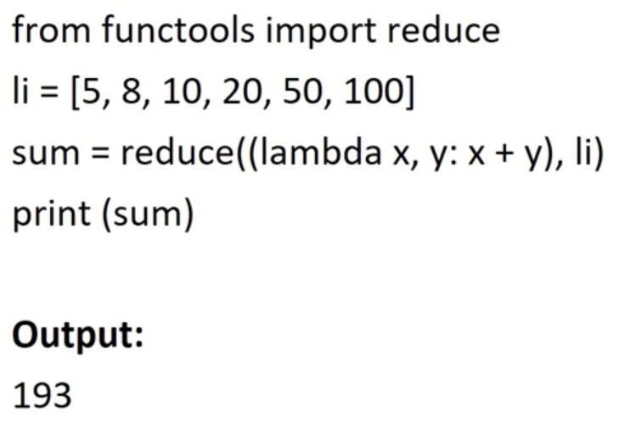

Series vs Dataframe: Series is 1 dimensional , while Dataframe is multidimensional.

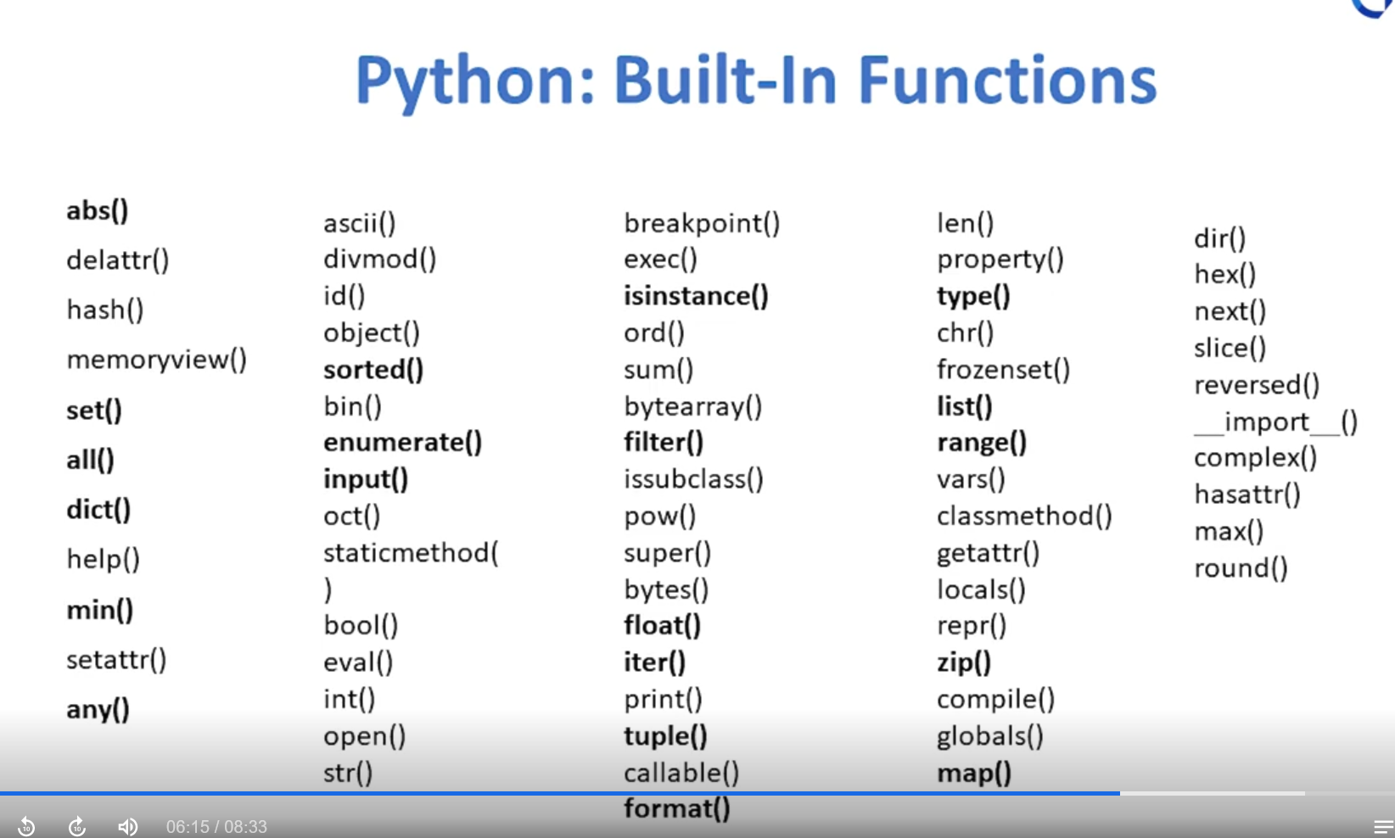

Only bold ones are important for interview.

Replace function:

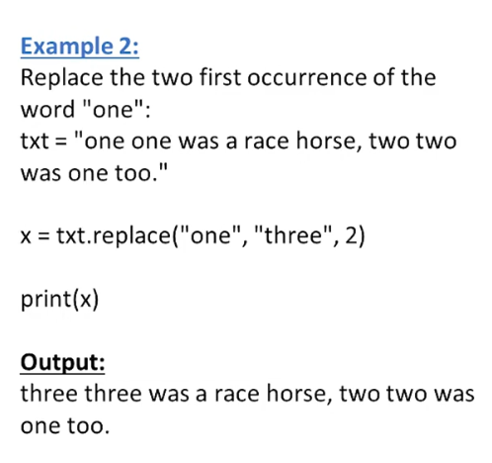

**OOP:**

Objective is to reduce program size.

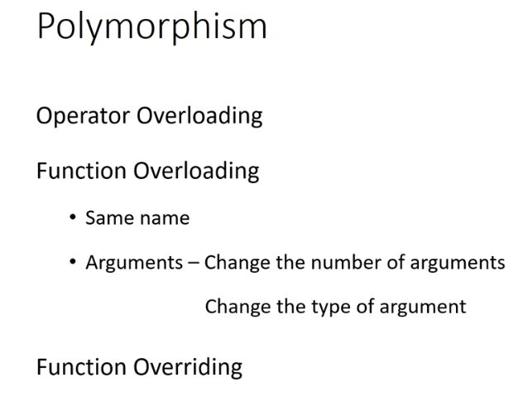

Function overriding is when they have same argument, and they are of same data type (Inheritance).

Ex: Hotstar has Free, VIP, and VIP+. VIP+ can access all features but free user can only access stuff.

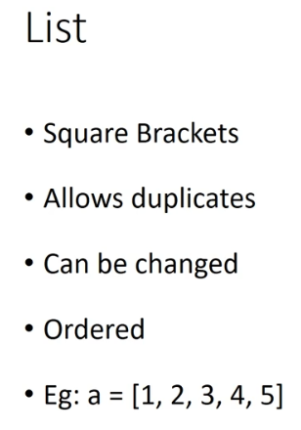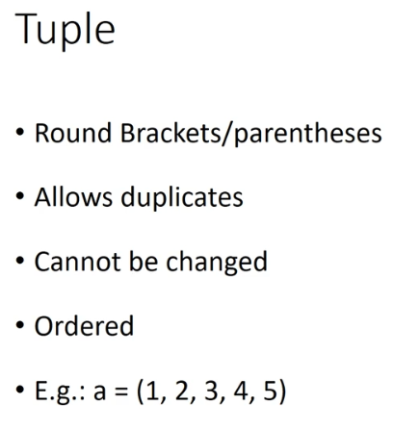

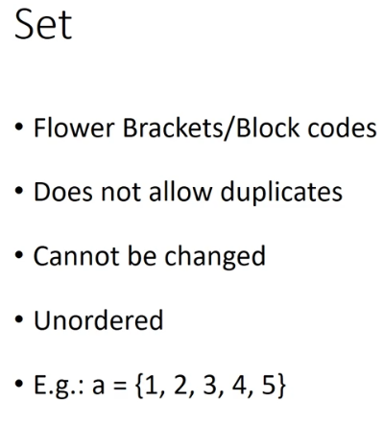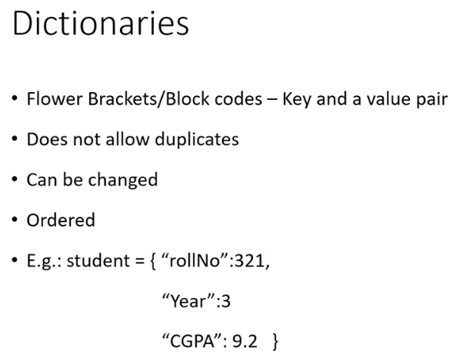

**Hypothesis:**

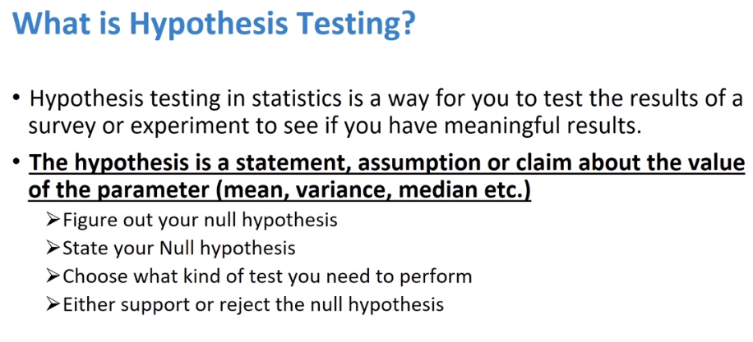

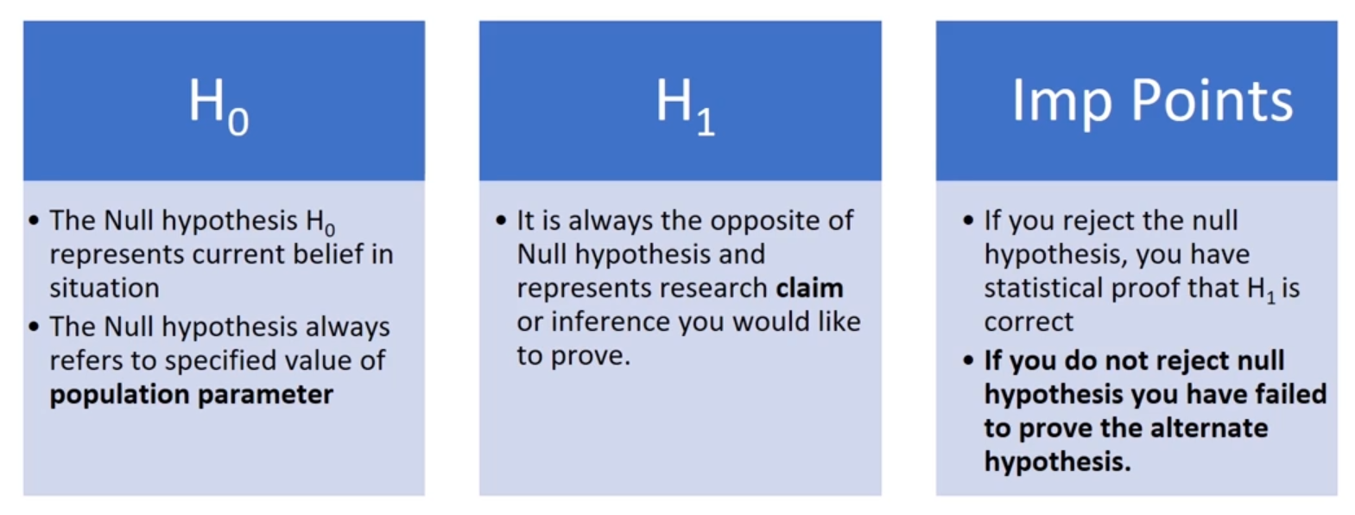

The claim will be H1, and your belief will be H0.

Do not say I accept Null hypo, instead say we fail to reject Null hypo.

Parametric assumption means there will be underlying assumption present.

Parametric has 2 types, 1 sample and 2 sample.

z-stat is based on **population** std dev, while t-stat is based on **sample** std dev.

In non parametric, no assumption present.

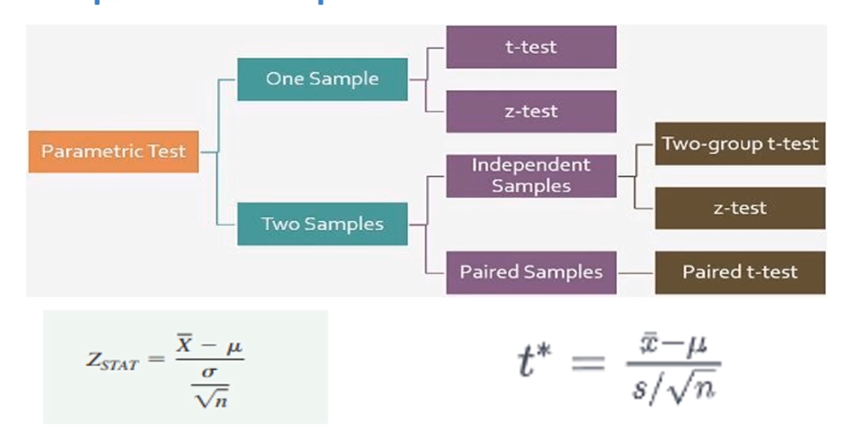

2 tailed test will have = in the null hypo or not equal to (!=) in the alternate hypo.

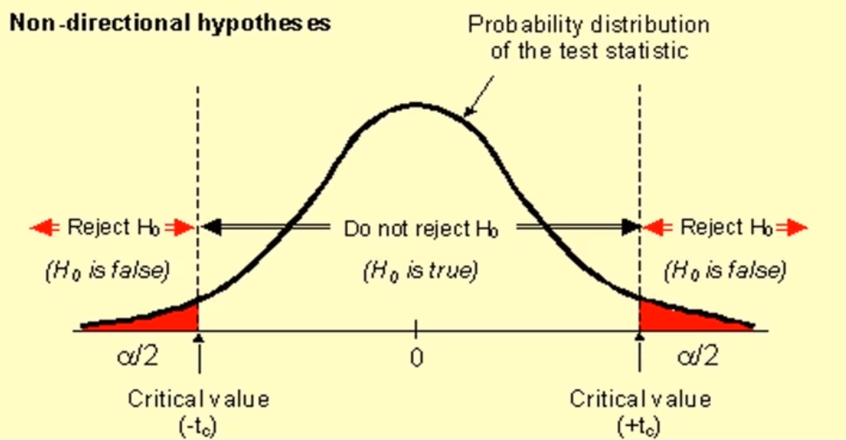

This is for 2 tail tests

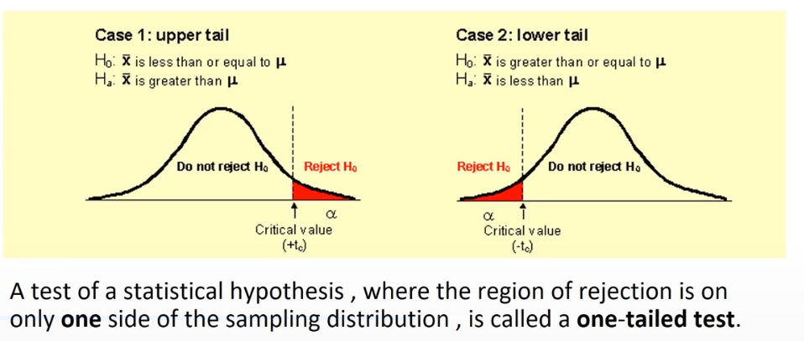

This is for 1 tail tests ( >= , <= )

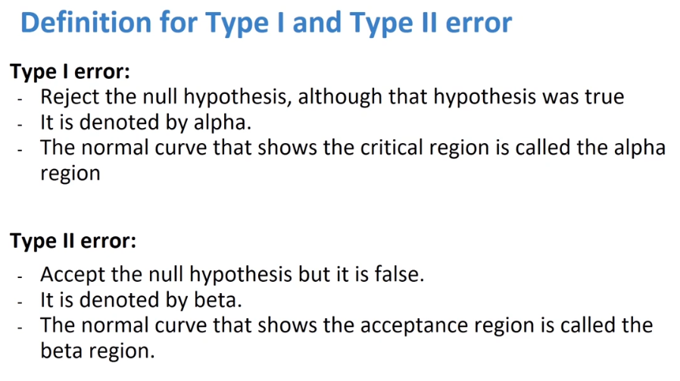

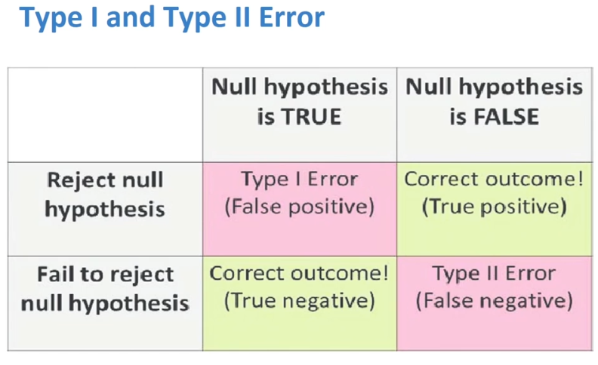

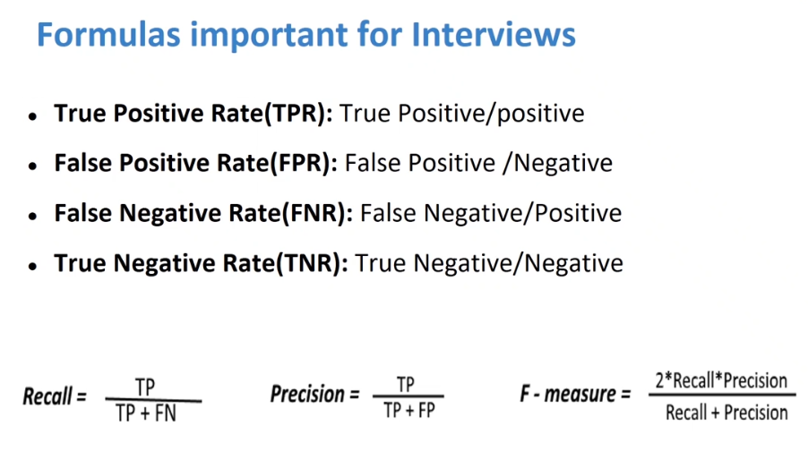

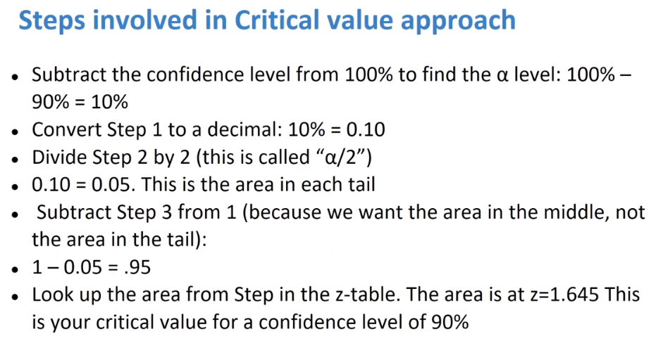

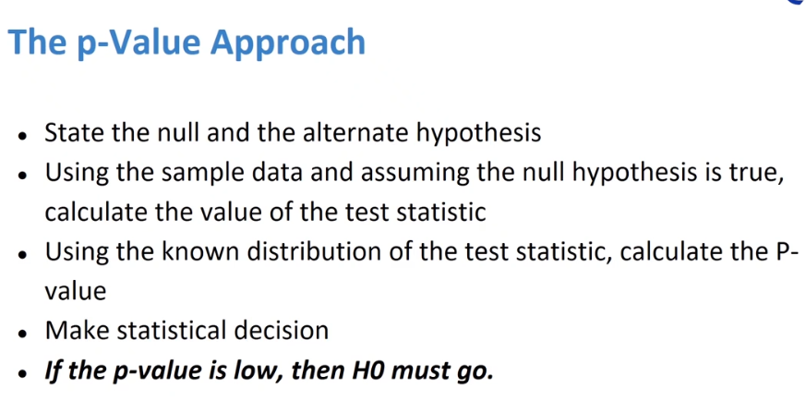

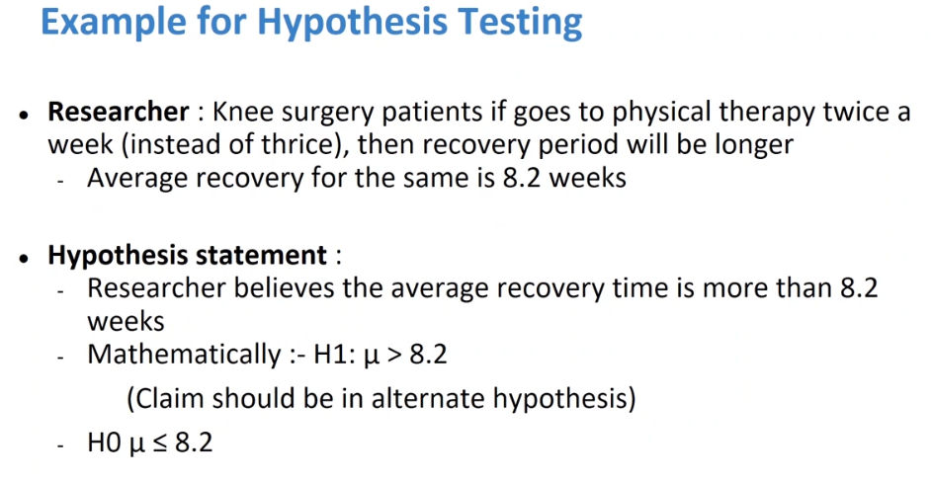

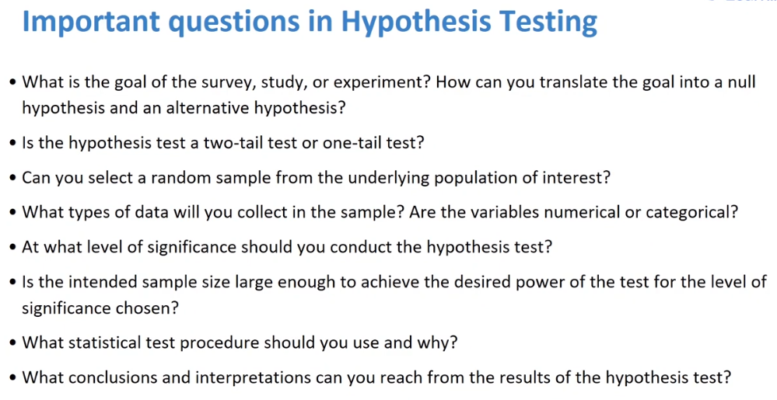

**Measures of Central Tendency:**

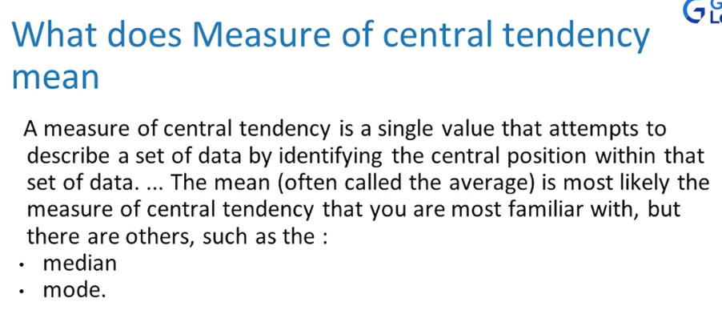

For Median, the values need to be sorted, but for mean that isn’t needed.

Mode is the item that occurs most number of times. No need for sorting.

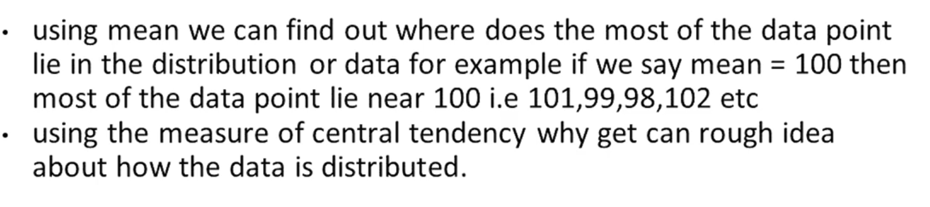

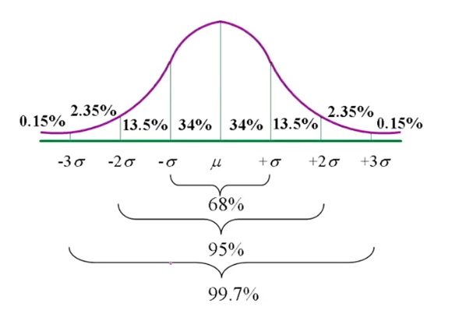

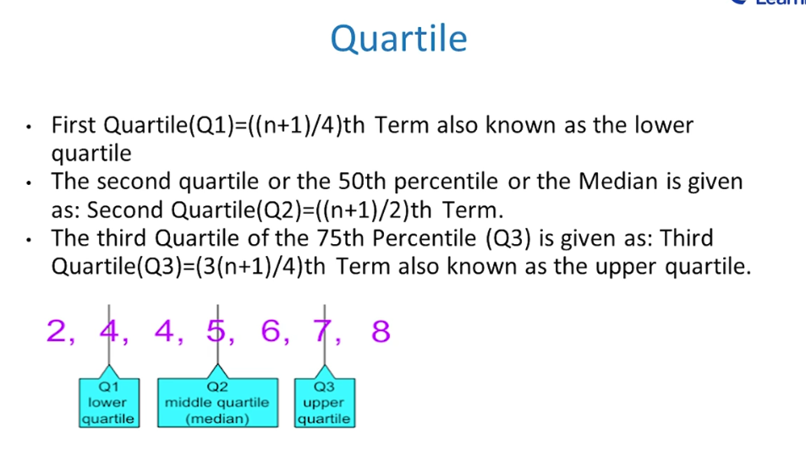

If std is very low, most data points are close to mean of data set, which means variability is very low.

_______________________________________

**Machine Learning:**

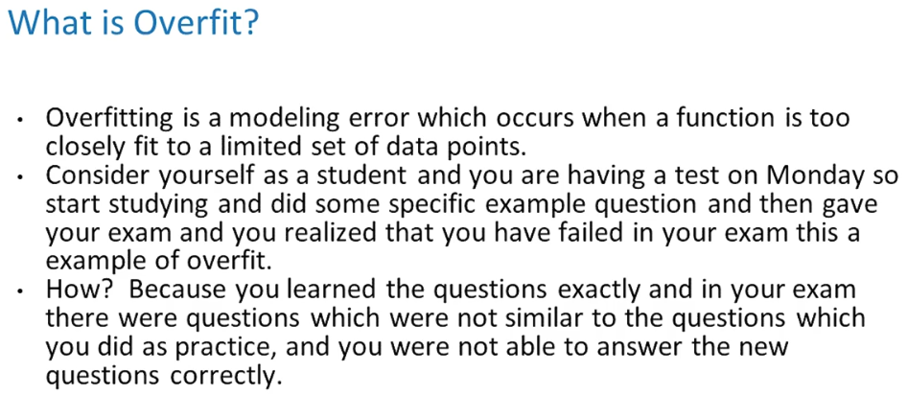

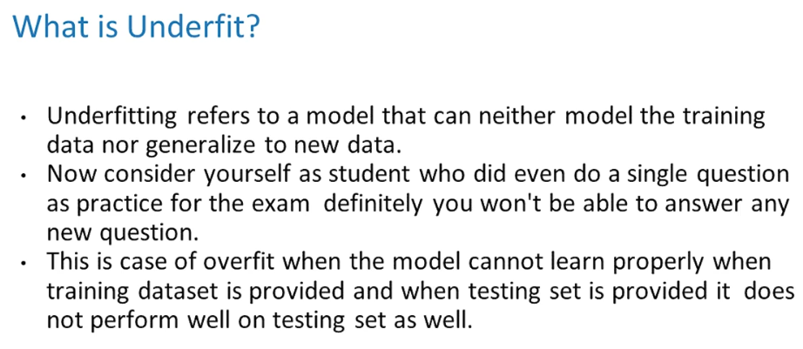

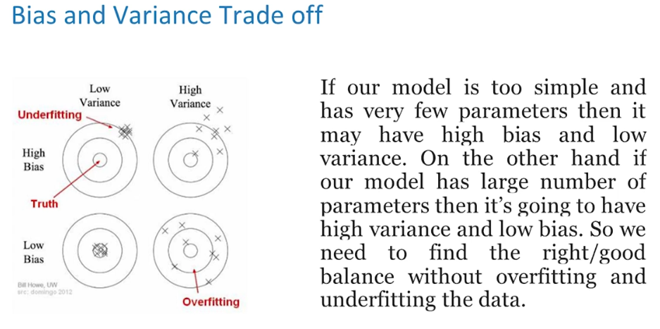

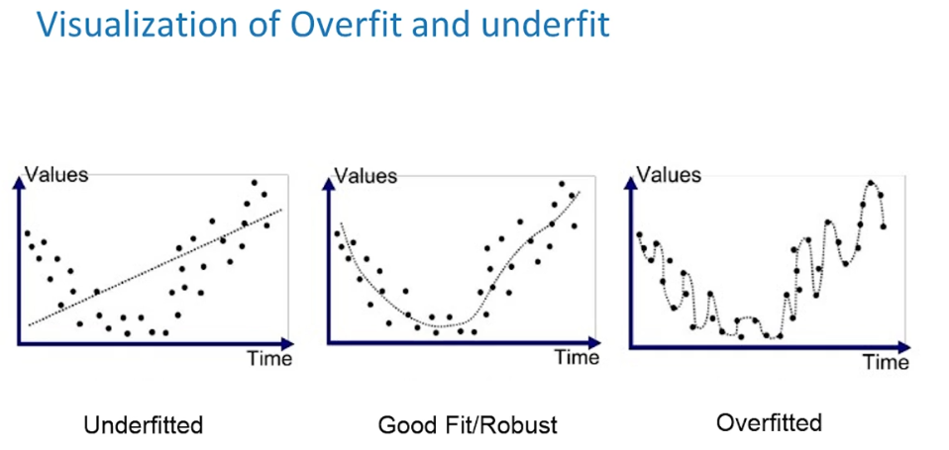

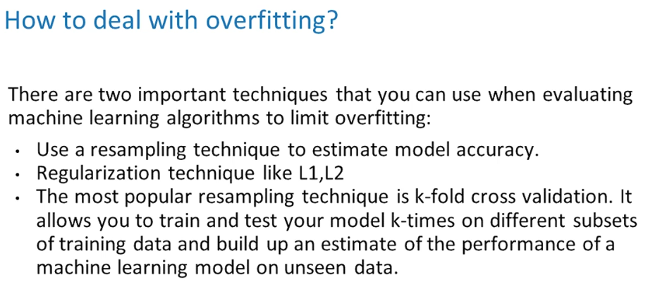

Why does decision tree overfit?

Because its based on if or else rule. It is exactly fitted. To solve this we use pruning techniques to avoid overfitting.

Random forest parallelly makes multiple trees.

At 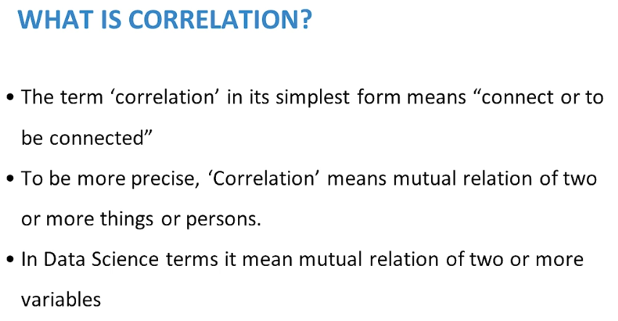

At ZERO corelation the Trend line will be parallel to X/Y axis and change in one does not affect the other.

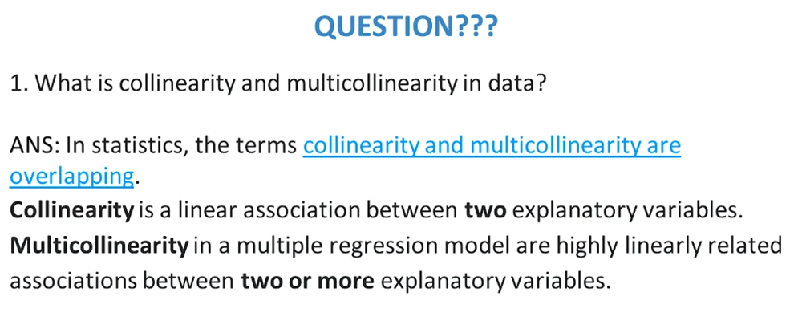

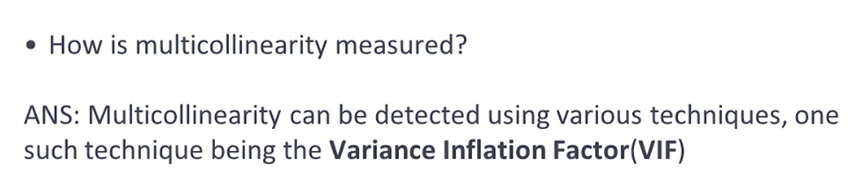

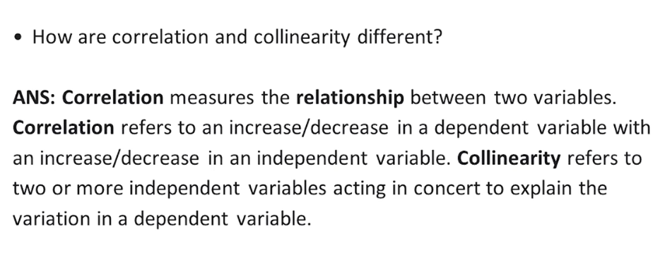

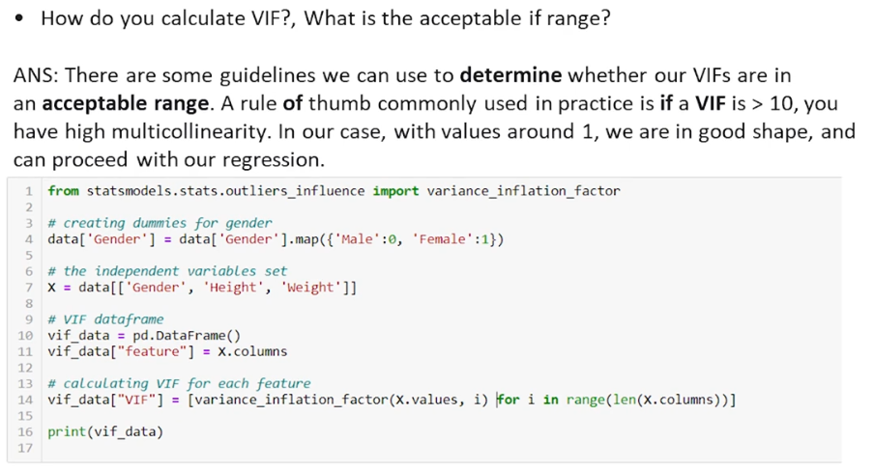

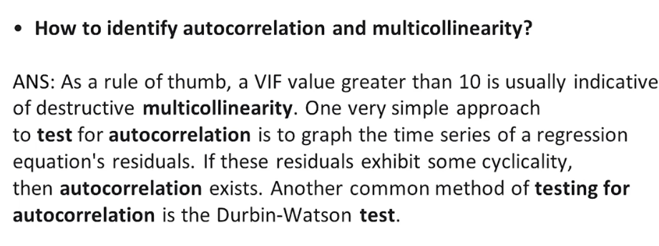

Autocorrelation is present in Time Series, which is what the time series models are based off.

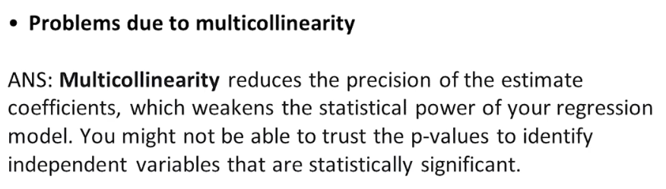

___________________________________________________________________

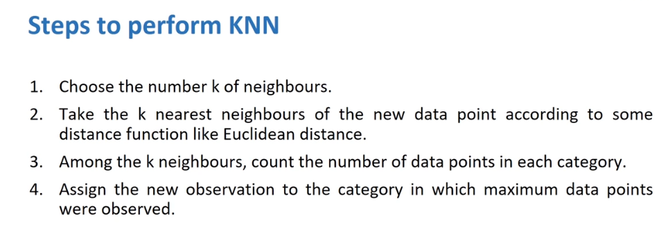

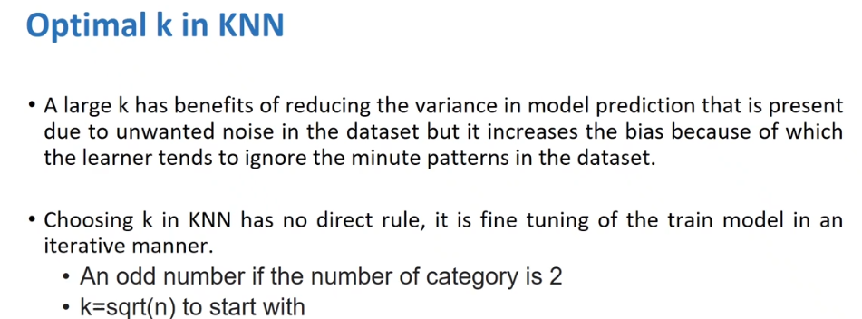

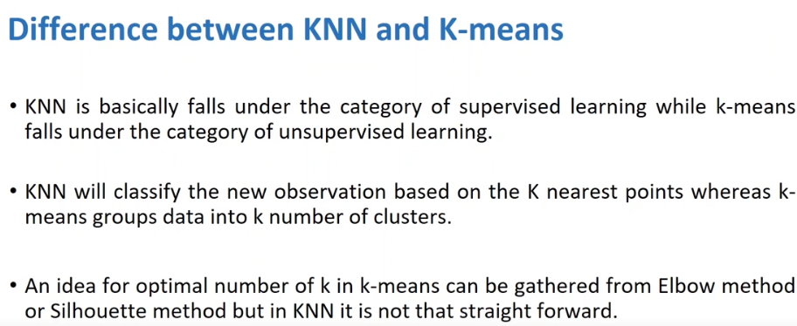

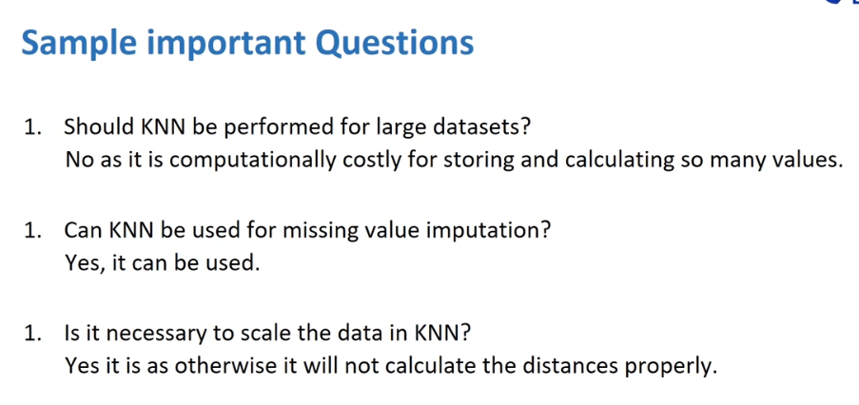

___________________________________________________________________________

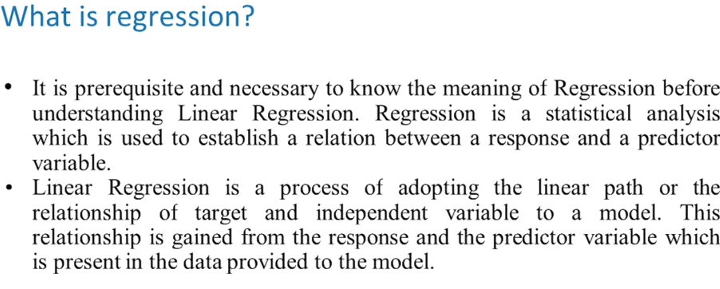

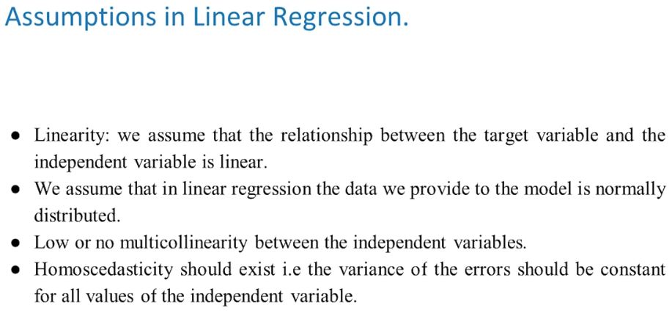

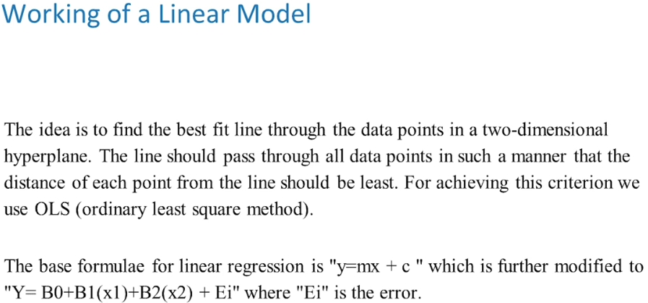

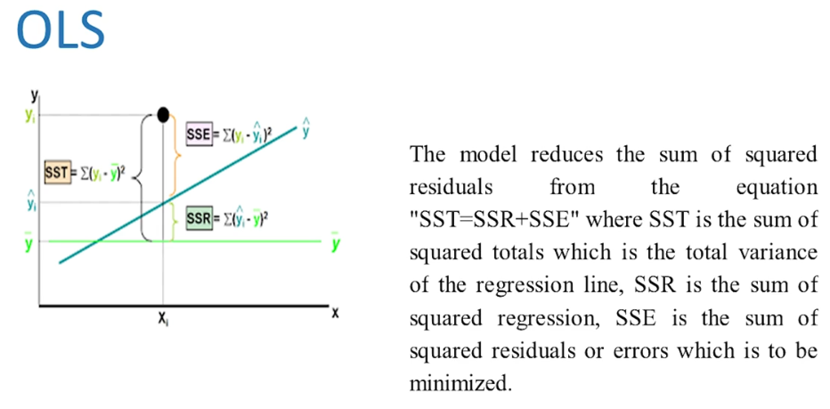

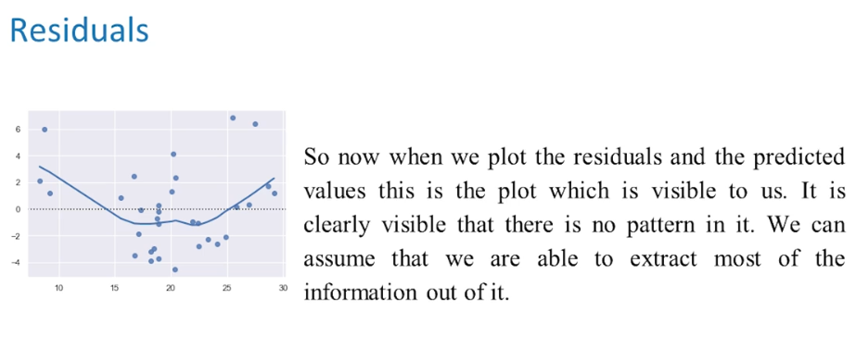

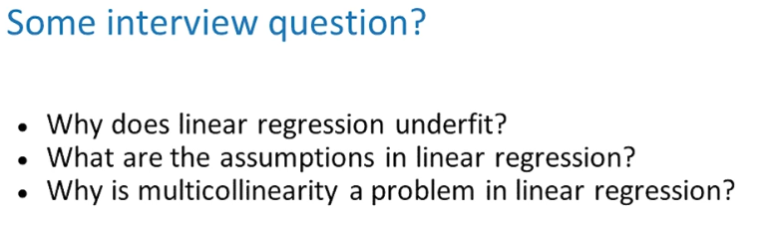

Linear relationship target and predictor variables.

Data should be normally distributed.

No multicollinearity.

Residuals follow homoscadecity.

________________________________________________________________________________

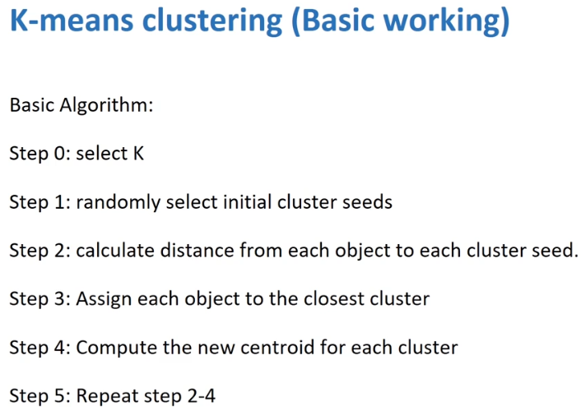

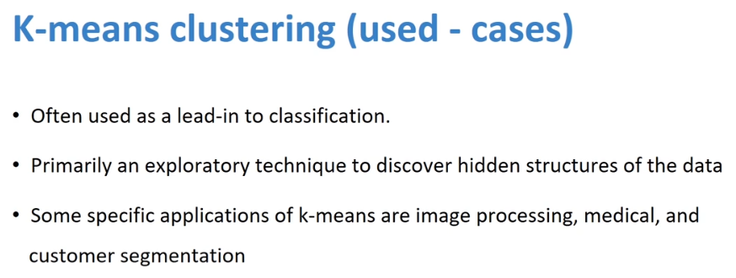

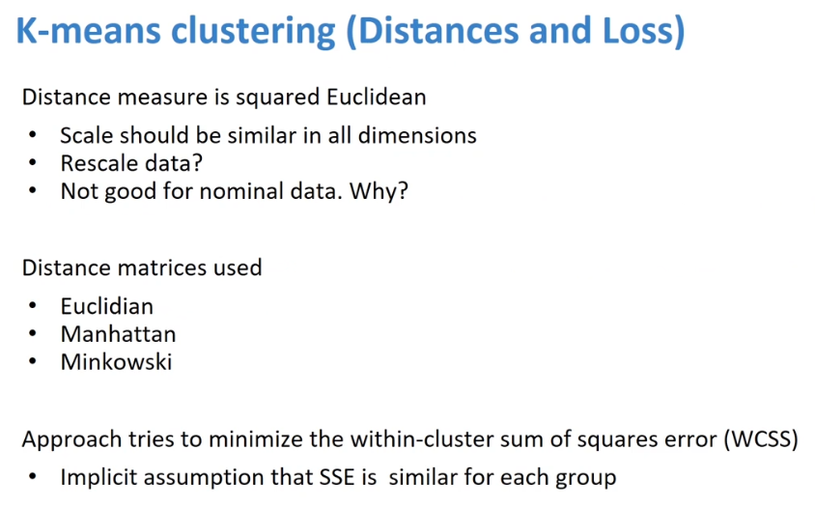

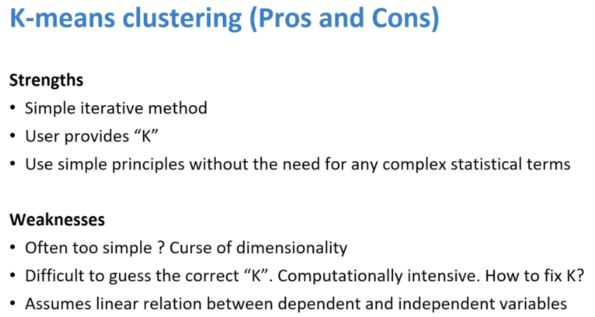

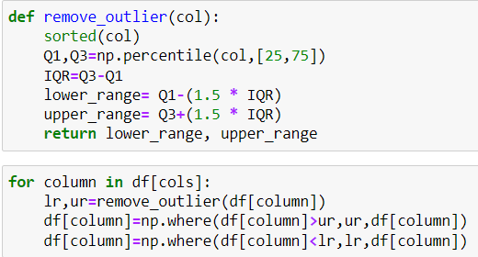

Note that **sklearn.OneHotEncoder** has been updated in the latest version so that it **does accept strings** for categorical variables, as well as integers.

Label encoding causes problem of model giving higher preference to higher numbers. This is overcome with onehotencding (creates additional columns), however we must be careful of dummy trap.

Dummy Variable Trap is a scenario in which variables are highly correlated to each other. The Dummy Variable Trap leads to the problem known as **multicollinearity**. Multicollinearity occurs where there is a dependency between the independent features. Multicollinearity is a serious issue in machine learning models like [Linear Regression](https://www.analyticsvidhya.com/blog/2017/06/a-comprehensive-guide-for-linear-ridge-and-lasso-regression/?utm_source=blog&utm_medium=one-hot-encoding-vs-label-encoding-using-scikit-learn) and [Logistic Regression](https://www.analyticsvidhya.com/blog/2015/11/beginners-guide-on-logistic-regression-in-r/?utm_source=blog&utm_medium=one-hot-encoding-vs-label-encoding-using-scikit-learn).

So, in order to overcome the problem of multicollinearity, one of the dummy variables has to be dropped.

df.sample() randomly select any =rows from dataframe.

**Statistics:**

Z-test: When sample size is greater than 30 (n>30) and population std dev is known.

T-test: (Popular):

One sample t test: when there is only 1 observation from one population.

Two sample t-test: when there is 2 independent observations from 2 different populations.

Paired t-test: when there is 2 dependent observations, i.e., before and after comparison.

(Degree of freedom is n-1 for 1sample and Paired t-test, and n1+n2-1 for 2 sample test)

Chi-square test is used on categorical variables. (Which means it will be cross tab (numerical))

(Degree of freedom is (m-1)(n-1), where m and n are rows and columns of the crosstab, not original data)

If its equal to (H0=H1) then its Two-tailed test.

If its >= or <=, then its One-tailed test.

